
Literature Review

Mepolizumab’s (Anti-Interleukin-5) Role in Asthma: A Literature Review
Dewi Wijaya1 , Indi Esha1 , Atikanur1 , Arya Marganda Simanjuntak2 ,
1 Department of Pulmonology and Respiratory Medicine, Faculty of Medicine, Universitas Riau, Arifin Achmad General Hospital, Pekanbaru, Indonesia
2 Medical School, Faculty of Medicine, Universitas Riau, Pekanbaru, Indonesia

Abstract  One type of asthma that is difficult to treat is severe asthma, which is asthma that is uncontrolled even when the patient is taking medication or trigger factors can be treated with the finest therapy but will worsen if high-dose treatment is discontinued. Age, gender, obesity, hypersensitivity, and immunological factors are all directly related to the onset of asthma. A complicated illness, severe asthma has a wide range of clinical symptoms and treatment choices. Chronic airway inflammation and lung tissue remodeling are its defining features. This review of the literature aims to describe how mepolizumab works in patients with severe asthma. Mepolizumab particularly inhibits the IL-5 cytokine from binding to IL-5 receptor subunits through the nanomolar potential, which inhibits IL-5 from binding to receptors on the surface of eosinophils. In contrast to the placebo group, patients on mepolizumab had an average 50% decrease from the baseline Prednisone dosage. With Mepolizumab, the yearly exacerbation rate was 1.44 RR, while it was 2.12 RR with placebo. The injection of monoclonal antibodies, such as mepolizumab, as a form of therapy in addition to treating severe eosinophilic asthma is advised by the GINA guideline for 2022. Mepolizumab's method of action blocks IL-5 from binding to receptors on eosinophil surfaces, which lowers eosinophil recruitment, activation, production, growth, and survival as well as eosinophil-mediated inflammation.  Keywords: Eosinophil, Interleukin-5, Mepolizumab, Severe Asthma | Corresponding Author:  Atikanur | Department of Pulmonology and Respiratory Medicine, Faculty of Medicine, Universitas Riau, Arifin Achmad General Hospital, Pekanbaru, Indonesia | atikanur.1987@gmail.com  Submitted: February 14th, 2021  Accepted: February 27^{h}, 2021  Published: February 28th, 2021  J Respirol Indones. 2021  Vol. 1 No. 2: 150-160  https://doi.org/10.36497/respirsci.v1i2.20

INTRODUCTION

One form of difficult-to-treat asthma is severe asthma, which is asthma that is uncontrolled even when the patient is taking medication or trigger factors can be managed with the best therapy but will go worse if high-dose treatment is stopped.^{1,2} Severe asthma, which is related to higher mortality, morbidity, persistent daily symptoms, hospitalization, and health care cost issues, as well as lower patient quality of life, affects fice to ten percent of all asthma patients.^{3,4} Treatment costs for those with severe asthma are sic times higher than those for people with mild and moderate asthma.⁵
Age, gender, obesity, hypersensitivity, and immunological variables all have a direct impact on asthma development.In 80% of kids over the age of 6, atopy is a risk factor for developing asthma^{1,5,6} According to research conducted in the Netherlands on asthma patients over the age of 18, 24% are receiving therapy according to steps four and five of the Global Initiative for Asthma (GINA) management recommendations. The group of people with difficult-to-treat asthma makes up 17% of the population, while the group of people with severe asthma makes up 7,7% of the 17%.^{1,7} Chronic airway inflammation and lung tissue remodeling characterize the diverse illness known as severe asthma, which has a range of clinical symptoms and therapeutic responses.^{5,8}
Mepolizumab significantly reduced the frequency of exacerbations, the use of oral corticosteroids (OCS), hospitalization, and emergency room visits in Shabbir et al’s study of the drug as an adjunctive therapy for severe eosinophilic asthma when compared to placebo.^{10,11} For selecting the appropriate target group and predicting biomarkers as an indication for administering mepolizumab in the therapy of severe asthma, knowledge of the pathobiology of asthma is helpful.¹² This literature review’s objective is to describe mepolizumab’s function in treating individuals with severe asthma.

Phenotypes, Endotypes and Biomarkers of Severe Asthma
According to GINA 2022, severe asthma is uncontrolled asthma even if the patient has had the best care possible, including high doses of Inhalation Corticosteroid-Long-Acting-Beta-Agonist (ICS-LABA) and the best management of precipitating events, or if asthma gets worse if high-dose treatment is discontinued. Correct inhaler use techniques, poor patient compliance, comorbidities (gastroesophageal reflux diseases, chronic rhinosinusitis, obstructive sleep apnea), precipitating factors, living, or working environment l(smoking, exposure to environment and allergens), frequent use of short-acting beta-agonist (SABA) reliever drugs, side effects of drugs, anxiety, and depression are some of the factors that contribute to symptoms, exacerbations.^{1,3,5}
If the causes underlying the asthma have dramatically improved after 3 to 6 months of appropriate medication, severe asthma is not taken into consideration.1 In comparison to mild to moderate asthma, severe asthma is associated with higher rates of morbidity, more frequent exacerbations, a higher risk of death, drug use, doctor visits, hospitalizations, OCS side effects, and health care costs that are six times higher. According to research done in England, people with severe asthma have higher healthcare costs than people with type 2 diabetes mellitus, stroke, and chronic obstructive pulmonary disease. Canadian research indicates that those with severe asthma are projected to spend over 60% more on healthcare than people with mild to moderate asthma.¹
In the Netherlands, a study on asthma patients over the age of 18 found that approximately 24 percent of the population was being treated in accordance with steps four and five of the GINA management guidelines, 17% of the population belonged to the group of patients with difficult-to-treat asthma, and approximately 3.7% of these patients had an asthma attack. The Asthma Control Test (ACT) assessment, adherence, and inhaler technique were used to determine the number of patients treated with high-dose ICS-LABA or moderate/high-dose ICS-LABA + long-term OCS who had poor symptom control.1,5,7 Asthma affects between 0.2 and 21% of persons worldwide. There are wide variations in the reported prevalence of severe asthma.^{3,15,17} In between 5 and 10% of persons, according to research by Miyokawa et al, suffer severe or hard-to-treat asthma.⁵
Chronic airway inflammation and lung tissue remodeling are hallmarks of the complicated illness known as severe asthma, which has a range of clinical symptoms and treatment effects. The molecular phenotypic, endotypic, biomarker, and treatment response variability of asthma is on the rise. The presence of an eosinophilic inflammatory process that is T-helper 2 (Th-2) defined is the main criterion for categorizing asthma. To optimize the use of specialized therapy, it is essential to establish the phenotypes, endotypes, and biomarkers of severe asthma (Fig. 1).⁵
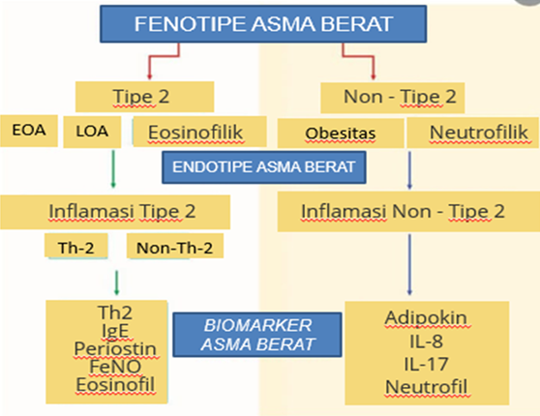
Figure 1. Phenotype, endotype and biomarkers of
severe asthma⁵

Severe Asthma Phenotype
The manifestation of a patient's characteristics, or phenotype, may be seen and made clear through interactions between the patient's environment and genotype, such as lung function and Immunoglobulin (IgE) (biomarker) responses to certain allergens. based on a combination of physiological, biochemical, and clinical traits. In a review of the literature, Noujeim et al. organized the phenotypes of people with severe asthma. These characteristics are divided into two groups: the inflammatory phenotype and the clinical phenotype. Severe asthma with recurring exacerbations, asthma with fixed airflow restriction (irreversible airway obstruction), and asthma needing systemic corticosteroids as therapy are the three clinical phenotypes. The two kinds of inflammation that make up the three phenotypes and paucigranulocytic (neutrophil eosinophil value normal) are chronic severe eosinophilic asthma (Eosinophil value >3%) and severe neutrophilic asthma (neutrophil value >61%), as illustrated in table 1.^{5,7}
Table 1. Characteristics of the severe asthma phenotype⁷
Clinical phenotype | Inflammatory phenotype
severe asthma with frequent exacerbations | persistent severe eosinophilic asthma
Asthma with obstructionfixed airflow | non-eosinophilic severe asthma with increased neutrophils
corticosteroid dependent asthma | paucigranulocytic severe asthma

Severe asthma of the type 2 and non-type 2 phenotypes were identified by Piuvezam et al. The Th2 immune response was used to identify a unique type 2 severe asthma phenotype. As indicators for severe asthma type 2, elevated CD4+ T cells are seen in bronchoalveolar fluid, mucosal biopsies, blood eosinophils, and airway eosinophils as well as high serum titers of allergen-specific IgE. The eosinophilic asthma, late-onset asthma, and early-onset asthma subtypes are the three subgroups of the severe asthma type -2 phenotype. When EOA, or allergic asthma, is linked to a family history of allergies, such as eczema, allergic rhinitis, food allergies, and medication allergies, it often manifests in children as the most easily identifiable phenotype. Some young children with early-onset asthma react effectively to corticosteroids and have reduced IgE levels. The EOA phenotype is significantly influenced by age. Compared to individuals with other phenotypes, pediatric patients with an early beginning of the severe atopic phenotype have a worse prognosis.^{5,6,13}
Adult-onset asthma, also known as late-onset asthma (LOA), is a condition that develops beyond the age of 65 and affects 8 – 10% of people. Most adult asthma patients, particularly women, initially develop asthma in their adult years. At 65 years of age, LOA patients have a 4 – 15% higher morbidity and mortality rate than young adults.^{1,2,6} Since late-onset asthma usually has no prior history of allergies, high-dose corticosteroid therapy is necessary. One of the most prevalent forms of LOA in modern nations is occupational asthma. Nasal polyps and sinusitis are frequently seen in adult-onset asthma with very high eosinophil levels. This phenotype demonstrates a connection between mast cells and basophils, two types of inflammatory cells, and type 2 cytokines.^{5,6,14}
In severe asthma, eosinophils are associated with eosinophils, which are granulocytic cells known as effector cells that produce and keep biologically active molecules, including cytotoxic proteins, namely major basic protein (MBP), eosinophil peroxidase (EPX), eosinophil cationic protein (ECP), eosinophil-derived neurotoxin (EDN), mediators. lipids, chemotactic peptides and other cytokines useful toward pathogens. Eosinophil granule protein is toxic to both pathogens and other cells during an immune response, resulting in tissue damage and ultimately organ failure. Eosinophils create and expel a large number of proinflammatory cytokines and chemokines..^{1,5,6,15}
Patients with non-type 2 severe asthma phenotypes frequently have obesity asthma and neutrophilic asthma. Obese asthmatic patients with the EOA phenotype had more bronchial hyperreactivity, a history of atopy, greater airway obstruction, higher serum IgE levels, and a higher risk of sensitization and allergic reactions than obese asthmatics with the LOA phenotype. In contrast to the predominance of severe asthma while being treated with corticosteroids, neutrophililic asthma is related with neutrophils because they are not linked to airway hyperreactivity.^{1,5,6} Clinical phenotypes of asthma include allergic, nonallergic, adult-onset (late-onset), chronic airflow limitation, and obese asthma, according to GINA 2022.¹

Endotype of Severe Asthma
Based on airway immune-mediated inflammation, type 2 (T2-high asthma) and non-type 2 (T2-low asthma) inflammatory responses are two endotypes of severe asthma (figure 2). Type 2 inflammation is a complex form of inflammation that encompasses innate and adaptive immune responses, asthma risk factors, allergy processes, as well as other inflammations. After allergens have already harmed these cells, dendritic cells start activating airway epithelial cells. Chemokines, which are chemotactic inflammatory mediators produced by epithelial cells, attract dendritic cells to the mucosal epithelium. Mature dendritic cells recognize allergens, present them to T cells via MHC classes I and II for T cell receptor recognition, and cause the activation of Th2 cells as antigen-presenting cells (APC)..^{5,6}
When Th2 cells activate IL-5, they also produce eosinophils. Once TGF- is produced by these eosinophils, fibroblasts are activated and the smooth muscles of the airways are contracted. Additionally, fibroblasts are stimulated by the IL-4 and IL-13 produced by Th2 cells. Mast cells stimulate Th2 cells, and Th2 cells stimulate B cells to create IgE, which constricts the smooth muscle of the airways. Proinflammatory cytokines and chemokines are produced and excreted in part by eosinophils. Nitric oxide (FeNO), serum periostin levels that are higher when there are more eosinophils in the sputum, poor asthma control, and a severe disease profile can all be used to predict severe eosinophilic asthma. On a fundamental level, it is still unknown what is generating the rise in FeNO. Periostin is released by airway fibroblasts and epithelial cells in response to the type 2 cytokines TGF and IL-4/IL-13.^{1,5,6}
Additionally, substances, cigarette smoke, and lipopolysaccharides (microorganisms) that cause non-type 2 inflammation are activated, as well as the innate immune system, Th1 and Th17 inflammatory pathways.^{5,6} IL-8 production, non-type 2 inflammation, high affinity IgE receptor expression, and an increase in neutrophils in the bronchi. Chemotactic cytokines (IL-8 and TNF-), which are secreted by neutrophils, macrophages, and epithelial cells, have an impact on the quantity of neutrophils in the airways. Neutrophils are attracted to IL-17 produced by T cells. Airway remodeling brought on by increased mucus production, airway smooth muscle hyperplasia/hypertrophy, and goblet cell metaplasia/hyperplasia define non-type 2 asthma. Non-type 2 asthma also has a function in neutrophil or paucigranulocytic inflammation that produces IL-8 and IL-17. ^{5,6}
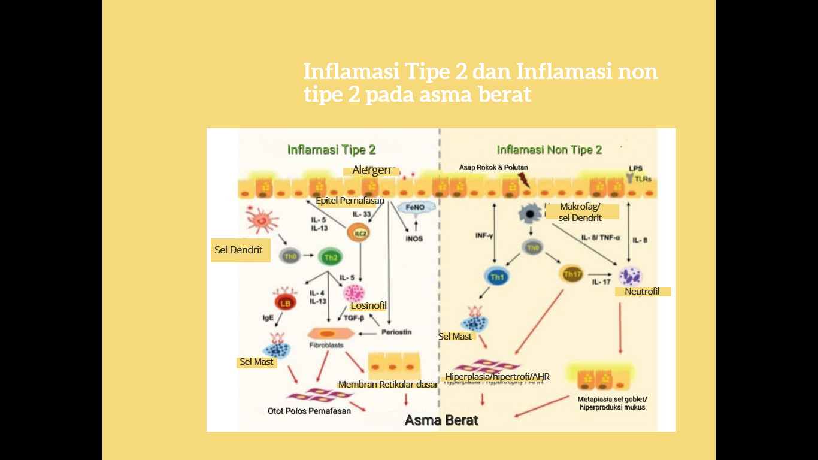
Figure 2. Type 2 inflammation and non-type 2 inflammation in severe asthma⁵

Severe Asthma Biomarkers
A biomarker is an indicator that links phenotype and endotype. Indicators can be measured and evaluated using a variety of biological materials, including sputum, brocoalveolar lavage (BAL), exhaled breath condensate (EBC), bronchial biopsies, urine, and blood. The effectiveness of various therapy approaches may be evaluated using biomarkers, as can the chance that a disease would emerge and the distinction between type 2 and non-type 2 inflammatory endotypes. Additionally, they can be used to predict how patients will respond to particular therapies, such as T2 cytokine-targeted therapy.15-18,32 The biomarkers for asthma are grouped by sample in Table 2. Through bronchoscopy, bronchial biopsy, and BAL examination, inflammation and asthma remodeling are assessed. For the evaluation of asthma, particularly in patients with severe asthma, biomarkers alone or in combination are recommended. Type 2 inflammation can be detected by the presence of periostin, FeNO, serum IgE, and blood or sputum eosinophils. A poor response to corticosteroid treatment and neutrophililic (sputum neutrophils >40%-60%) or paucigranulocytic (sputum eosinophils and neutrophils normal) inflammation are characteristics of non-type 2 inflammation. The ability of neutrophils, a non-type 2 inflammatory biomarker, to predict asthma severity and anti-inflammatory mechanisms is limited.¹³
Table 2. Severe asthma biomarkers¹⁶
Biomarker | Sample type | Associated asthma endotypes
Eosinophils | Serum, sputum | Type-2
Neutrophils | Sputum | Type-2/non-type-2
IgE | Serum | Type-2
Periostin | Serum | Type-2
FeNO (fractional exhaled nitric oxide) | Exhaled air | Type-2
IL-17 | Serum | not type-2
EBC (exhaled breath condensate) | Exhaled air | Not specified
VOCs (volatile organic compounds) | Exhaled air | Not specified

Selection of Severe Asthma Treatment
The GINA 2022 recommendations for treating severe asthma include using a high-dose ICS-LABA combination for 3-6 months as well as optimizing the treatment of steps 4-5 in the event that good asthma control cannot be achieved with the use of a medium-dose ICS plus LABA and a third controller (LTRA or theophylline). a LAMA (long-acting muscarinic antagonist), either alone or in combination with a medium-dose ICS-LABA, or zithromax three times per week.¹
Clinical biomarkers and patient-focused asthma endotypes should be taken into account while providing supplementary biologic treatment to persons with severe asthma. If you have severe allergic asthma and high IgE levels, you might think about further anti-IgE therapy (omalizumab). Mepolizumab, reslizumab, and benralizumab are additional anti-IL-5/IL-5 receptor drugs for persons with severe asthma and elevated blood eosinophil levels. The administration of duplilumab, an additional anti-IL-4R drug, results in greater levels of FeNO when using the strategy shown in Figure 3 to select an empiric biologic therapy for severe asthma.¹
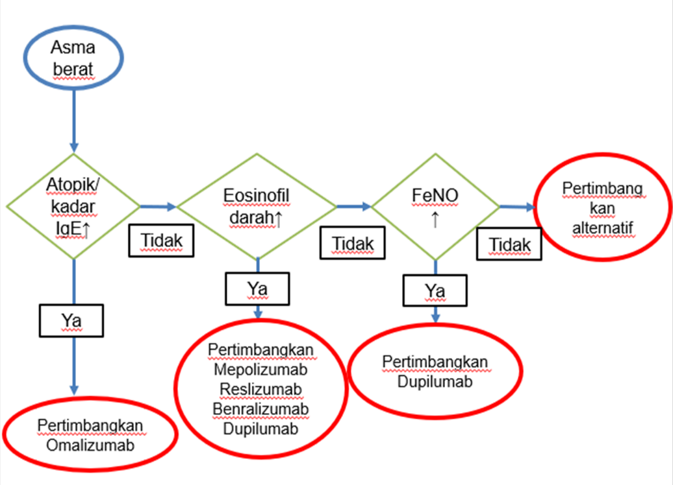
Figure 3. Algorithm for selection of biologic treatment for severe asthma²

Mepolizumab (Anti Interleukin-5) Mechanism of Action and Clinical Use
In order to stop IL-5 from attaching to receptors on the surface of eosinophils, mepolizumab precisely prevents IL-5 cytokine binding to IL-5 receptor subunits via the nanomolar potential (figure 4). Interleukin-5 is the main cytokine in charge of eosinophil synthesis, differentiation, migration, activation, and survival. Anti-IL-5's capacity to inhibit eosinophil recruitment, activation, generation, growth, and survival reduces eosinophil-mediated inflammation. In just 24 hours, mepolizumab therapy can reduce blood eosinophil levels by up to 50%..^{14,15}
In patients receiving high-dose inhaled corticosteroids along with one or more controllers, such as LABA, mepolizumab is used to treat severe persistent asthma in adults, adolescents, and children aged 6 years and older with an eosinophil count of 150 cells/L at the beginning of treatment or 300 cells/L in the previous 12 months. Mepolizumab and a placebo were evaluated in eight studies by the Cochrane Airways Group, involving 1707 participants. In one randomized research with 621 individuals, administration of mepolizumab 75 mg, 250 mg, or 750 mg at four-week intervals led to eosinophilic inflammation. Blood eosinophil levels significantly dropped among mepolizumab users.²³
Mepolizumab significantly decreased the annual number of exacerbations as compared to placebo in a study including 806 asthma patients who had exacerbations while receiving OCS treatment. a 48% decrease at a dosage of 75 mg. Patients with severe eosinophilic asthma who had gone through two exacerbations in the previous year were given mepolizumab 100 mg subcutaneously. When compared to those who took a placebo, 194 of the 449 patients who experienced exacerbations reported a reduction in exacerbations of 1.74 relative risk (RR) or 0.83.²³
In a study, mepolizumab was administered subcutaneously to 135 patients with severe eosinophilic asthma who had been on 5-35 mg of prednisone for six months. The patients were assessed 20 weeks after getting mepolizumab or a placebo while still taking corticosteroids. The trial's findings demonstrated that mepolizumab users saw an average 50% reduction in Prednisone dosage from the starting dose, whilst the placebo group did not see a corresponding drop. With mepolizumab, the yearly exacerbation rate was 1.44 RR as opposed to 2.12 RR with a placebo. ²³
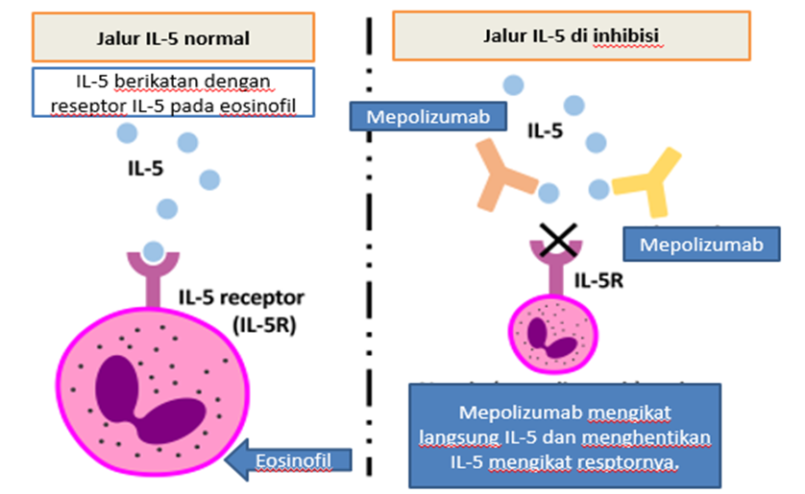
Figure 4. Mepolizumab mechanism of action²⁶

Pharmacodynamics of Mepolizumab
In a study by Russell et al, mepolizumab was given subcutaneously at a dose of 100 mg once every four weeks to patients with severe eosinophilic asthma in both adults and adolescents. This treatment was found to be more effective than a placebo in lowering blood eosinophil levels, which decreased from an initial average of 290 cells/L to 40 cells/L in the sixth week.32 Between 4 weeks and 4.5 years, the average time it took for the blood eosinophil levels to decline was 2.8 years. Every four weeks for a total of 52 weeks, children aged 6 to 11 years got mepolizumab subcutaneously. Blood eosinophil levels dropped further after the 40 mg dosage (for a weight of 40 kg) than the baseline average of 306 cells/L, down to 48 cells/L after 52 weeks. These data demonstrate 85% and 87% declines, respectively, after the start of the treatment.²⁴
Mepolimuzab should be administered parenterally or intravenously to individuals with eosinophilic asthma once every four weeks for 32 weeks, and once every four weeks to patients with eosinophilic granulomatosis polyangiitis. Children under 12 receive the same dosage as an adult, whereas children aged 6 to 11 receive 40 mg once every four weeks for 52 weeks. Mepolizumab comes in vials, prefilled syringes, and prefilled autoinjectors in 10 mL colorless translucent glass bottles with bromobutyl rubber (non-latex) covers, aluminum top seals, and plastic flip tops. 100 mg of powder for injectable solution are contained in each vial. Since a single-use bottle doesn't contain any preservatives, reconstitution needs to be completed in an aseptic setting.²¹

Pharmacokinetics Mepolizumab
According to a study by Russell et al, treating patients with severe eosinophilic asthma with mepolizumab at a dose of 100 mg subcutaneously every four weeks reduced blood eosinophil levels compared to placebo administration, going from an initial average of 290 cells/L to 40 cells/L in the sixth week.³² Between 4 weeks and 4.5 years, this decrease in blood eosinophil levels lasted an average of 2.8 years. Every four weeks for a total of 52 weeks, mepolizumab was administered subcutaneously to children aged 6 to 11 years. Blood eosinophil levels dropped further after the 40 mg dosage (for a weight of 40 kg) than the baseline average of 306 cells/L, down to 48 cells/L after 52 weeks. Blood eosinophil levels dropped further after the 40 mg dosage (for a weight of 40 kg) than the baseline average of 306 cells/L, down to 48 cells/L after 52 weeks. These numbers demonstrate 85% and 87% declines, respectively, since the start of the treatment.²⁴
Mepolimuzab should be administered parenterally or intravenously to individuals with eosinophilic asthma once every four weeks for 32 weeks, and once every four weeks to patients with eosinophilic granulomatosis polyangiitis. Children under 12 receive the same dosage as an adult, whereas children aged 6 to 11 receive 40 mg once every four weeks for 52 weeks. Mepolizumab comes in vials, prefilled syringes, and prefilled autoinjectors in 10 mL colorless translucent glass bottles with bromobutyl rubber (non-latex) covers, aluminum top seals, and plastic flip tops. 100 mg of powder for injectable solution are contained in each vial. Since a single-use bottle doesn't contain any preservatives, reconstitution needs to be completed in an aseptic setting.²¹

Pharmacokinetics Mepolizumab
Patients with severe asthma receive subcutaneous injections of mepolizumab at a dosage ranging from 12.5 mg to 250 mg. Tmax, which ranges from 4 to 8 days, is a measure of the median time to maximum plasma concentration and it shows that absorption is slow. Mepolizumab's absolute bioavailability was 64%, 71%, or 75% in the belly, thigh, and arm after subcutaneous injection. Mepolizumab accumulation in patients with severe asthma ranged from 74 to 80% when administered subcutaneously, and after repeated injections every four weeks, it was found to be nearly twice as high.¹¹
Following a single intravenous infusion, the volume of distribution of mepolizumab in people with severe asthma ranges from 55 to 85 mL/kg. Mepolizumab undergoes biotransformation to become a monoclonal antibody, which is widely distributed throughout the body and degraded by predominate proteolytic enzymes in liver tissue. After a single intravenous administration, the terminal half-life was around 20 days, the subcutaneous half-life ranged from 16 to 22 days, and the systemic clearance ranged from 1.9 to 3.3 mL/day/kg. There, gallbladder secretion occurs. Mepolizumab has an estimated systemic clearance of 3.1 mL/day/kg, according to a pharmacokinetic study. Mepolizumab doesn't have any known drug interactions.¹⁹
In preclinical tests, the monoclonal antibody mepolizumab was not shown to be genotoxic or carcinogenic. The drug product is chemically and physically stable while it is still in the carton, maintained in the refrigerator at 2°C-8°C, and shouldn't be frozen until it is used, according to research on the use of mepolizumab with dilution. At 30°C outside of the refrigerator, unopened medication storage is possible for up to 7 days. Mepolizumab must be given soon away to prevent pharmaceutical destruction and microbiological contamination 8 hours after the seal is broken. Medication are put in boxes to protect them from direct light and out of children's reach.²¹

Benefits and Safety of Mepolizumab
Mepolizumab specifically inhibits IL-5 in eosinophilic inflammation and lowers the amount of sputum and blood eosinophils, which reduces exacerbations, the need for OCS, and improves asthma control, according to the same-named study presented at the international congress of the European Respiratory Society (ERS) and published in the New England Journal of Medicine (NEJM). In this placebo-controlled research, 576 patients were randomly assigned to 3 groups, and every four weeks for 32 weeks, either placebo, mepolizumab 100 mg subcutaneously, or mepolizumab 75 mg intravenously, were administered. Clinically significant differences were found between the exacerbation rates of Mepolizumab and placebo, with Mepolizumab administered intravenously to 47% of patients and subcutaneously to 53% of patients.^{21,25}
Mepolizumab was given to 135 individuals with severe eosinophilic asthma who were taking oral glucocorticoids in the Steroid Reduction with Mepolizumab Study (SIRIUS). Compared to the placebo group, the Mepolizumab group exhibited decreased dependency on oral glucocorticoids, according to the data (odds ratio, 2.39; 95% confidence range, 1.25–4.56; p=0.008). There was no difference in the percentage of mean reduction from baseline consumption of glucocorticoids by 50% between the Mepolizumab group and the placebo group. Both subcutaneous and intravenous administration of mepolizumab are equally beneficial in decreasing exacerbations, improving quality of life, and minimizing the requirement for oral glucocorticoids.²⁵

Contraindications and side effects of drugs
Special consideration should be given to patients who take steroids, have a history of parasitic worm infection, herpes zoster, are children, pregnant, or breastfeeding. Mepolizumab's primary contraindication is hypersensitivity to the medication's components. Negative side effects were common and included headaches (19%), nasopharyngitis (18%), and hypersensitivity reactions (1–10%). Local reactions were seen at 38% of injection locations. The frequency of local symptoms including soreness, edema, erythema, itching, and burning subsided after the first three injections. Other common reactions include musculoskeletal problems like back pain or muscle spasms, skin diseases including pruritus and dermatitis, and digestive system problems like stomach discomfort.²³ Depending on the patient's evaluation cycle, response to therapy, risk of aggravation, and drug side effects, decide how to treat asthma patients.¹

CONCLUSION
The 2022 GINA recommendations state that severe asthma remains uncontrolled despite optimal patient adherence to high-dose ICS-LABA and effective management of precipitating causes or worsening asthma when high-dose therapy is discontinued. The injection of monoclonal antibodies, such as mepolizumab, as a form of therapy in addition to treating severe eosinophilic asthma is advised by the GINA guideline for 2022. Mepolizumab's method of action blocks IL-5 from binding to receptors on eosinophil surfaces, which lowers eosinophil recruitment, activation, production, growth, and survival as well as eosinophil-mediated inflammation. Mepolizumab is effective in improving quality of life, lowering the need for oral corticosteroids, and reducing the frequency of asthma attacks.

Acknowledgments
We would like to express our gratitude to Dr. Indra Yovi, Sp.P(K), Head of the Pulmonology and Respiratory Medicine Department at Arifin Achmad General Hospital in Riau Province.

Conflict of Interest

All authors declare no conflict of interest

Funding

All authors declare no organization/individual fund support for this article

REFFERENCE

- Global initiatiative for asthma (GINA). Global strategy for asthma management and prevention. 2022.
- Dragonieri S, Carpagnano GS. Biological therapy for severe asthma. Asthma res and pract. 2021; 7: 12‒9.
- Csoma Z, Gai Z, Gezsi A, Herjavez I, Szalai C. prevalence and characterization of severe asthma in Hungary. Sci reports. 2020; 4: 41‒9.
- Salmi ST, Lemmetyinen R, Chanoine S, Karjalainen J, Pekkanen J, Bousquet J et al. Risk factor for severe adult-onset asthma. BMC pulmonary med. 2021; 23: 125‒32.
- Piuvezam MR, Ferreira LKDP. Severe asthma update therapy approach based on phenotype and biomarker. Intechopen. 2018; 8: 36‒49.
- Perhimpunan Dokter Paru Indonesia. Pedoman diagnosis & penatalaksanaan asma di Indonesia. 2021.
- Noujeim C, Khalil PB. Severe asthma moving from phenotype to endotype classification with updates on treatment. J nurs care. 2016; 12: 66‒71.
- Agache I, Akdis CA. EAACI biologicals guidelines-recomemndations for severe asthma. Wiley allergy. 2021; 76: 14-44.
- Gibson PG, Prazma CM, Chupp GL, Bradford ES, Forshag M, Mallett SA, et all. Mepolizumab improves clinical outcomes in patients with severe asthma and comorbid conditions. Respir Res. 2021; 22: 171-9.
- Shabbir S, Pouliquen IJ, Bentley JH. The pharmacokinetics and relative bioavailability of mepolizumab 100 mg liquid formulation administered subcutaneously to healtyy participants. Clinical pharm in drug development. 2020; 64: 31‒9.
- Morjaria JB, Emma R, Fuochi V. An evaluation of mepolizumab for the treatment of severe asthma. Jl expert opinion on biological therapy. 2019; 7: 16‒29.
- Jin HJ. Biological treatments for severe asthma. Yeungnam univ J med.2020; 37 (4): 262-8.
- Pelaia C, vatrella A, Busceti MT. Severe eosinophilic asthma from pathogenic role of interleukin-5 to the therapeutic action of mepolizumab. Drug design, development and therapy. 2017; 11: 3137-44.
- Nakagome K, Nagata M. involvement and possible role of eosinophils in asthma exacerbation. Frontiers in immunology. 2018; 8: 144‒52.
- Wenzel SE. Severe adult asthma integrating clinical features, biology and therapeutics to improve outcomes. Concise clinical review. 2020; 27: 236‒49.
- Magnan A, Bourdin A, Prazma CM. Treatment response with mepolizumab iun severe eosinophilic asthma patients with previous omalizumab treatment. Eur j of allergy and clinical immunology. 2016; 71:1335-44.
- Cavaliere C, Frati F, Ridolo E. The spectrum of therapeutic activity of mepolizumab. Expert review of clinical Immunol. 2019; 3: 65‒74.
- Numata T, Miyagawa H, Kawamoto H. predictors of the enhanced response to mepolizumab treatment for severe eosinophilic asthma. Congent med. 2020; 8: 36‒54.
- Roufosse F, Kahn JE, Killon AD. Efficacy and safety of mepolizumab in hypereosinophilic syndrome a phase III randomized pacebo controlled trial. Biologics and immunotherapy. 2020; 10: 36‒49.
- Khatri S, Moore W, Gibson PG. Asssessment of the long-term safety of mepolizumab and durability of clinical response in patients with severe eosinophilic asthma. Asthma and lower airway disease. 2018; 81: 236‒49.
- Karp J, Dhillon I. Subcutaneous mepolizumab injection an adjunctive treatment for recalcitrant allergic fungal rhinosinusitis patients with asthma. American j of rhinology and allergy. 2020; 2: 1-8.
- Taille C, Chanez P, Didier A. Mepolizumab in a population with severe eosinophilic asthma and corticosteroid dependence. Original article asthma. 2019; 9: 436‒49.
- Harrison T, Canonica GW, Chupp G, Lee J. Real-world mepolizumab in the prospective severe asthma REALITI- a study. Original article asthma. 2020; 19: 63‒79.
- Russell R, Brightling C. Mepolizumab for the reduction of exacerbations in severe eosinophilic asthma. Expert review of resp med. 2016; 8: 31‒9.
- Ortega HG, Liu MC, Pavord ID, Brusselle GG, FitzGerald JM, Chetta A, et al.; MENSA Investigators. Mepolizumab treatment in patients with severe eosinophilic asthma. N Engl J Med. 2014; 371: 1198-207.

