**PUBLISHING AGREEMENT**

We, the undersigned below:

Name : Dr.dr.Budi Yanti, Sp.P(K)

Institution : Medicine Faculty, Universitas Syiah Kuala

Mailing Address : Tanoh abe, Darussalam, Banda Aceh

Number Phone : 08126913805

Email : byantipulmonologis@usk.ac.id

We GIVE full approval to the Jurnal Respirologi Indonesia to publish our article and the tools contained therein (if needed) entitled:

**Pneumothorax Primary Spontaneous In Healthy Tall And Thin Male Secondary To Smoking: A Case Report And Literatur Review**

We provide a statement:

1. We have compiled this article without any act of plagiarism and all sources, both quoted and referenced, have been properly stated.
2. The material in this article has never been published before and is not in the process of being published in other scientific journals.
3. We have the rights to the article and have never given the copyright of the article to anyone
4. We permit the Jurnal Respirologi Indonesia for all rights to production, distribution, reuse, and inclusion of part or all of the articles, including recompilation or stand-alone in any form of media now or in the future, including all electronic and digital media, under protection applicable laws in the Republic of Indonesia and foreign countries and to authorize other parties to use the article properly. This authorization will become the property of the Jurnal Respirologi Indonesia as of the date of receipt of the article for publication.
5. Authors are allowed to hold the copyright of articles.
6. The article is free from plagiarism and is not the result of other people's work as evidenced by TurnItIn check results below 20%.
7. Willing to pay a publication fee of Rp. 1.000.000,00 or US$ 75,00

Banda Aceh, 28 May 2023

First Author/Corresponding Author,

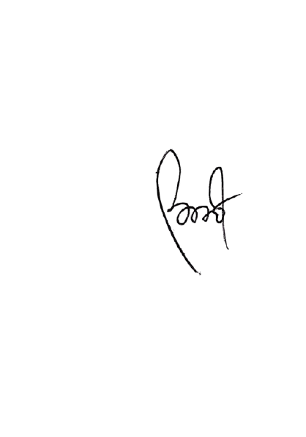

(Dr.dr.Budi Yanti, Sp.P(K)

*Select one